# Micah Hoffmann Assignment 1

Contents

Micah Hoffmann Assignment 1 1

Overview 1

Create Project 1

Create ASP.NET folder and create summoner class 2

Create Default.aspx web page that will display the summoner class info 3

Add JavaScript to insert image 5

## Overview

This is an intro web program that I would like to build on moving forward. The goal with this application is to pull data and display it based on specific queries and interactions.

## Create Project

Creating as basic ASP.NET .NET Framework – Empty – web application.

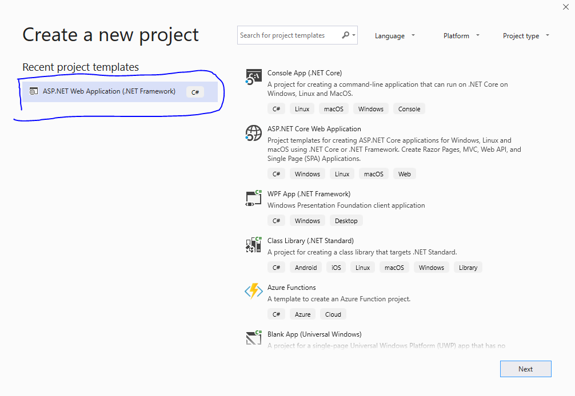

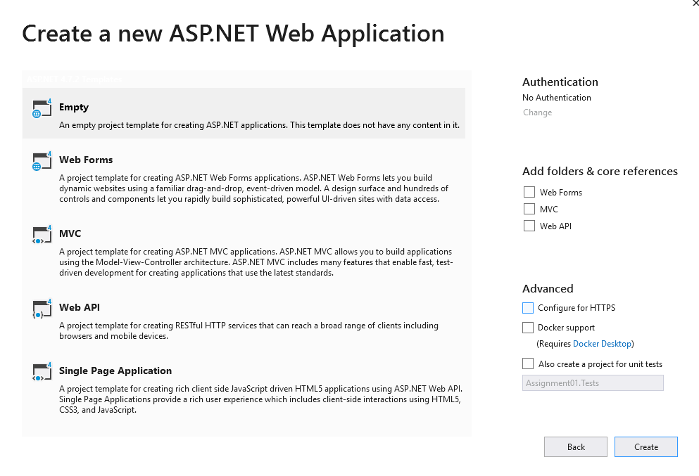

## Create ASP.NET folder and create summoner class

This will be the constructor for the summoner information as a C# class.

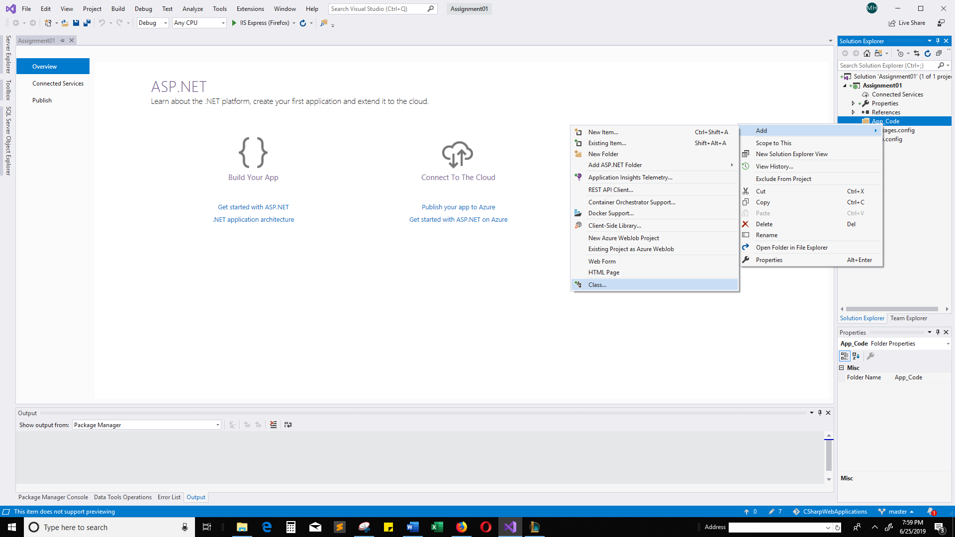

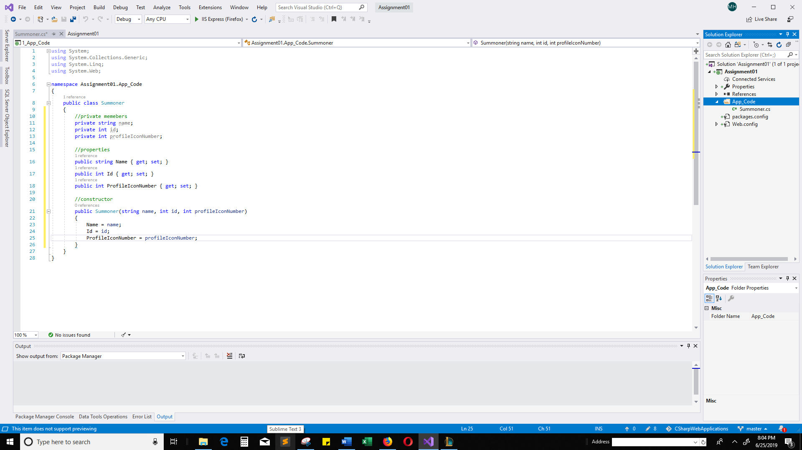

## Create Default.aspx web page that will display the summoner class info

Note: The only way I have found to resolve the namespace issue, is by deleting the namespace container in the Summoner.cs class. Any ideas?

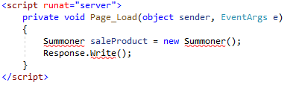

namespace Assignment01.App_Code

{}

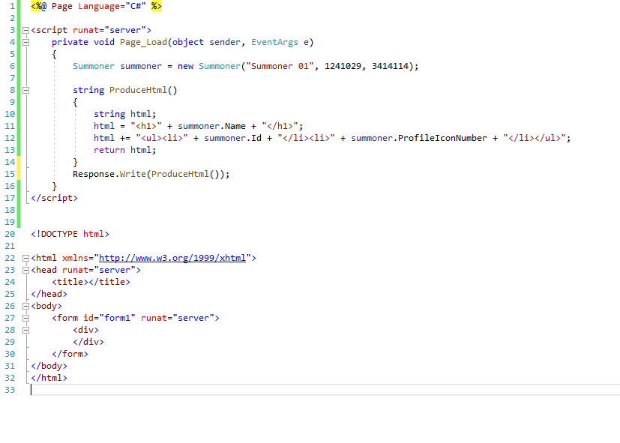

Test….

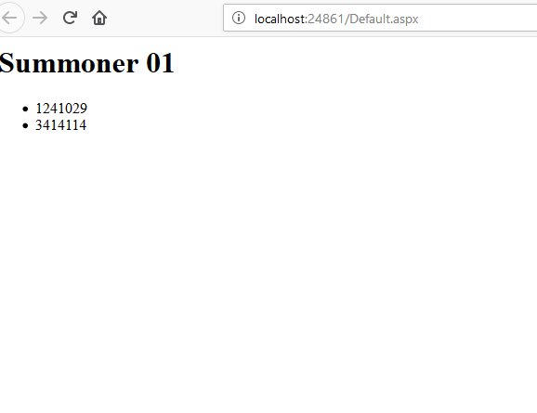

## Add JavaScript to insert image

That is very boring, so I will add some JavaScript that will use the summonerIconNumber to insert an image into the html

